**MVMS RoboTech Meeting** #1

**Date:** 8/4/2014 **Start Time:** 7:00PM **End Time:** 9:00PM

**Attended:** Brandon Ho, David Huang, Sauhaarda Chowdhuri

**Tasks**

* In the last meeting coach gave us a challenge to design a robot arm that can lift a ring that is lying 6 to 8 inches from its base. We worked independently during the week and came up with some designs. Review the different designs we thought of.
* Decide on a final design for actual implementation

**Reflections**

1. We decided on a robot arm that has three degrees of freedom.
2. Learnt about forward kinematics of a robot arm.
3. Learnt basic concepts of force and torque.

**Body**

Brandon presented his robot design. He made a model of his arm using LEGO parts. We liked his chain-gear mechanism which kept the motor load low and did not add to the arm weight. Brandon also presented his Auto-desk CAD of the robot arm.

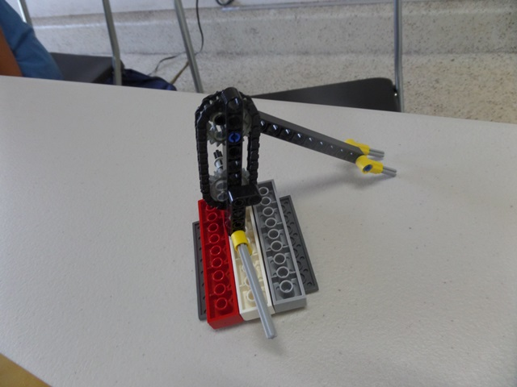

David presented his design. His arm has 3 degrees of freedom. His design uses motor for each joint.



Sauhaarda showed us his robot arm design in Auto Desk Inventor. He also talked about a Java program he wrote to decide the length of each joint and how much each joint needs to rotate to reach all possible position where the ring may be kept.

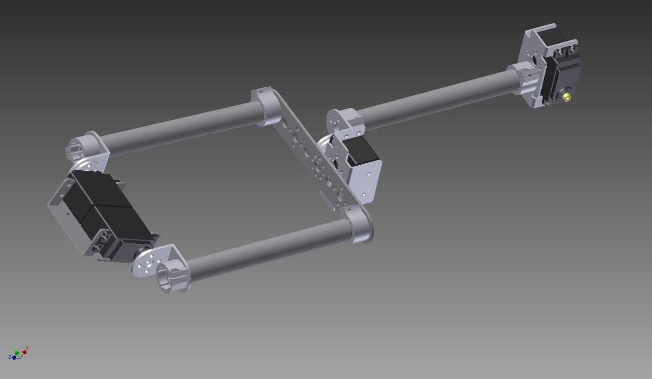

We had not considered the torque required in joint because we did not know about the concept of torque. Coach gave a short tutorial on torque.

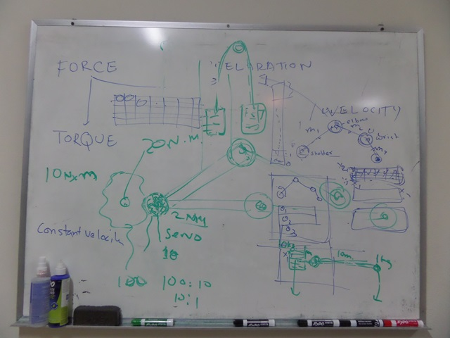

We thought of extending Sauhaard’s program to include max torque for each motor. We also thought of making this program available to other teams through our webpage which can be helpful for designing a robot arm.

**The tasks for the next meeting:**

1. Sauhaarda to expand his Java program to include max torque.
2. David to come up with some test cases and using mathematics manually.
3. David and Brandon to come up with a robot claw design
4. Brandon to create Auto desk design for the claw and possibly make a LEGO prototype.